

School of Informatics and Engineering, Blanchardstown

Automated spirulina bioreactor

by

John Benedict Ocampo Divinagracia

A report submitted in partial fulfillment of the

requirements for:

Ordinary Bachelor of Engineering Degree

in Mechatronics

Supervisor: Mary Looby

Submission Date: 11/10/2024

Project management plan

Project management plan i

LIST OF TABLES ii

LIST OF abbreviations iii

Chapter 1 Project Management 1

1.1 Project brief and description 1

1.1.1 Project deliverables 2

1.1.2 Project due dates (milestones) 3

1.1.3 Project tasks 4

1.1.4Work Breakdown Structure 4

1.1.5 Initial Gantt chart and explanation 4

LIST OF TABLES

* List of abbreviations
* Tábla 1: project deliverables
* Tábla 2: project due date milestones
* Tábla 3: Project tasks

LIST OF abbreviations

|  |  |
| --- | --- |
| ESP32 | Espressif Systems 32-bit Microcontroller |
| PLC | Programmable Logic Controller |
| pH | Potential of Hydrogen (Measure of Acidity/Alkalinity) |
| BOM | Bill of Materials |
| 3D | Three-Dimensional |

# Chapter 1 Project Management

## Project brief and description

The central issue in this biomedical project is ensuring the survival and growth of the spirulina culture, a microorganism highly dependent on specific environmental conditions. The most critical component is the air pump, which provides oxygen to the spirulina. Oxygen is essential for its metabolism, and without it, the entire culture will spoil. A failure in the pump system could result in the loss of a full batch, making pump reliability a top priority. To address this, the system must include failsafes such as backup pumps or sensors that detect and respond to pump malfunctions in real-time.

In addition to oxygenation, maintaining optimal pH and temperature levels is crucial. Spirulina grows best when the pH is between 6.0 and 9.0, and the temperature is between 24°C and 30°C. Any deviation from these ranges can drastically reduce growth rates or kill the culture. The system needs continuous monitoring and adjustment capabilities to ensure these conditions are always met. Sensors, actuators, and feedback loops will be key to maintaining these parameters, but they introduce potential points of failure in the system. Sensor calibration, malfunctioning actuators, or software glitches could compromise the system's effectiveness.

Beyond the biological challenges, there are several potential problems in delivering the project itself. Ensuring seamless integration between the ESP32 microcontroller, PLC, and various sensors is critical, and there’s a risk of communication issues between these components. Proper synchronization of sensor data and actuator control must be flawless to avoid delays or incorrect responses, which could jeopardize the cultivation process. Additionally, the complexity of building a robust, fail-safe control system with limited user input introduces technical challenges in both hardware design and software development. Manufacturing the device to precise specifications, while staying within budget and time constraints, adds another layer of difficulty. Therefore, rigorous testing and validation are required at every stage to minimize risks and ensure project success. This could be mitigated by checking each systems if they are working properly.

• Prototype 1: Ensure pump integration with ESP32.

• Prototype 2: Calibrate sensors and integrate with ESP32.

• Prototype 3: Combine sensors, actuators, and microcontroller.

• Prototype 4: Physical infrastructure build.

• Prototype 5: System assembly and testing.

## 1.1.1 Project deliverables

Tábla 1: project deliverables

|  |  |
| --- | --- |
| 11th October | Project management plan |
| 8th November | Electronic design schematic |
| 15th November | Mechanical design drawings |
| 22nd November | Simulation video of the control software design |
| 29th November | Updated project management plan and bill of materials |
| 6th December | Progress presentation slides |
| 13th December | Interim report |
| 28th February | Mechanical build |
| 4th April | Final project |
| 11th April | Final report |

* + 1. Project due dates (milestones)

Tábla 2: project due date milestones

|  |  |
| --- | --- |
| Chose project idea | 26 Sep |
| Decide on project concept | 4 Oct |
| Project management plan document | 11 Oct |
| Determine Top-level designs | 3-Nov |
| Detailed Electronic Control Design Schematic | 7 Nov |
| Integration test on pump with ESP 32 (prototype 1) | 9 Nov |
| Integration test on sensors with ESP 32 (prototype 2) | 12 Nov |
| Detailed Mechanical Design Drawings | 15 Nov |
| Control Software Design and Simulation Video | 22 Nov |
| Project Management Plan Update and Final BOM | 29 Nov |
| Presentation Slides start | 6 Dec |
| Interim Report | 13 Dec |
| Integrating all sensors, actuators and the microcontroller (prototype 3) | 20 Dec |
| Mechanical design prototype (canisters) | 20 Jan |
| Mechanical design prototype (control unit housing) | 10 Feb |
| Mechanical Build (prototype 4) | 28 Feb |
| Integration, Testing and Troubleshooting (prototype 5) | 20 Mar |
| Calibration and Final Adjustments (prototype 6) | 25 Mar |
| Project Deadline - Demonstration | 4 Apr |
| Final Report and Function Video | 11 Apr |

## 1.1.3 Project tasks

The project is broken down into designs and phases or prototypes

Tábla 3: Project tasks

|  |  |
| --- | --- |
| Design 1 | Project design |
| Design 2 | Electronic design |
| Design 3 | Mechanical design (drawings) |
| Prototype 1 | Integration test on pump with ESP 32 |
| Prototype 2 | Integration test on sensors with ESP 32 |
| Prototype 3 | Integrating all sensors, actuators and the microcontroller |
| Prototype 4 | Mechanical Build |
| Prototype 5 | Integration, Testing and Troubleshooting |
| Prototype 6 | Calibration and Final Adjustments |

## 1.1.4Work Breakdown Structure

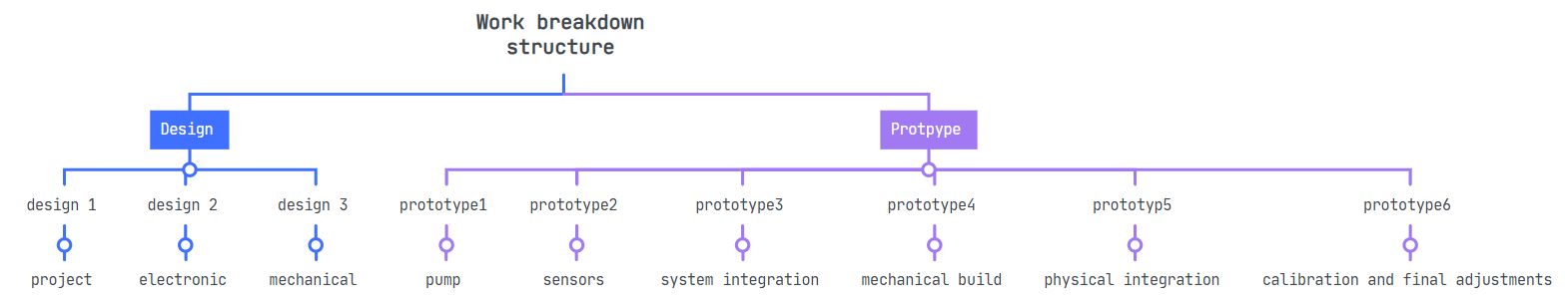

## 1.1.5 Initial Gantt chart and explanation

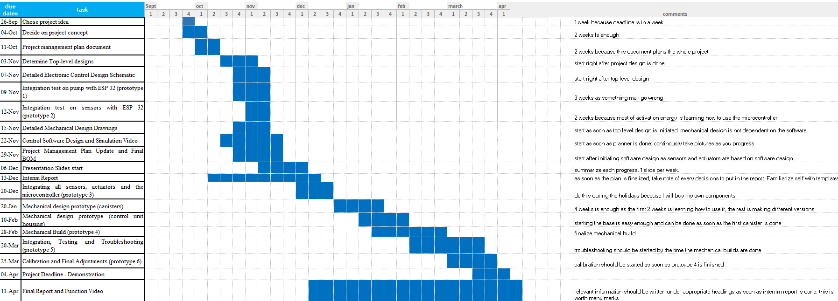

Every month is assumed to have 4 weeks for simplification

Comments are within the excel image